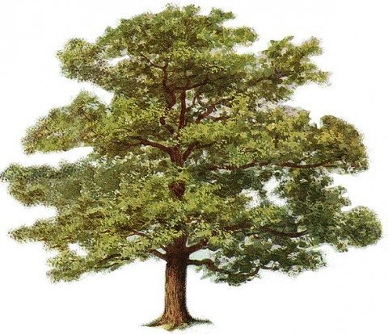

***End of every verse:***

The tree was in a hole and the hole was in the ground and the green grass grew all around all around, and the green grass grew all around.

**Ask Me**

about my echo song about a tree in the woods.

This is a cumulative song, so we add something new every verse!

**In the Woods**

1. Oh, in the woods...there was a tree...

The prettiest little tree...that you ever did see....

1. Now on that tree...there was a branch...

The prettiest little branch that you ever did see...

The branch was on the tree and the tree was in the hole....

1. Now on that branch...there was a nest....
2. Now on that nest...there was an egg....
3. Now on that egg...there was a bird....
4. Now on that bird...there was a wing...
5. Now on that wing...there was a bug...
6. Now on that bug...there was a germ...
7. Now on that germ...there was a smile...

***End of every verse:***

The tree was in a hole and the hole was in the ground and the green grass grew all around all around, and the green grass grew all around.

**Ask Me**

about my echo song about a tree in the woods.

This is a cumulative song, so we add something new every verse!

**In the Woods**

1. Oh, in the woods...there was a tree...

The prettiest little tree...that you ever did see....

1. Now on that tree...there was a branch...

The prettiest little branch that you ever did see...

The branch was on the tree and the tree was in the hole....

1. Now on that branch...there was a nest....
2. Now on that nest...there was an egg....
3. Now on that egg...there was a bird....
4. Now on that bird...there was a wing...
5. Now on that wing...there was a bug...
6. Now on that bug...there was a germ...
7. Now on that germ...there was a smile...