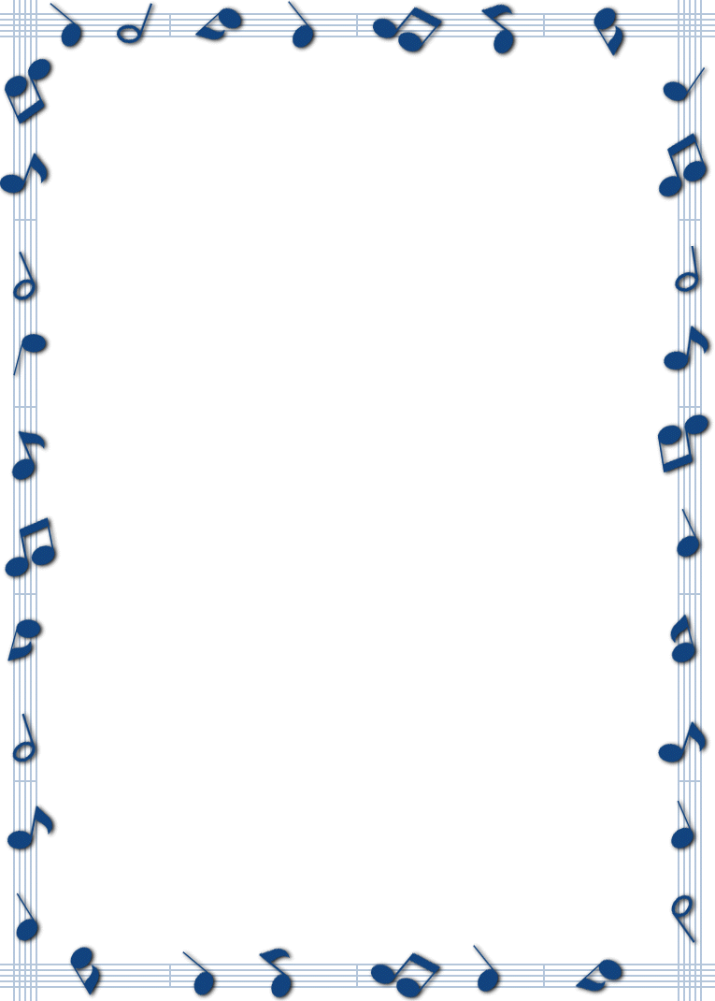ASK ME

About my fingerplay

This week we learned the word TEMPO: the speed of the music!

To remember what tempo means, say this rhyme:

Tempo is fast and slow!

Do Your Ears Hang Low?

(Repeat the song 3x making the TEMPO faster on each repeat)

Do your ears hang low?

(*wave hands with thumbs touching near ears)*

Do they wobble to and fro?

*(place palms together and push back and forth)*

Can you tie them in a knot?

*(roll hands one over the other)*

Can you tie them in a bow?

*(pull hands apart)*

Can you throw them over your shoulder,

*(hold hands together and lift up to one shoulder)*

Like a continental soldier?

*(salute with one hand)*

Do your ears hang low?

(*wave hands with thumbs touching near ears)*