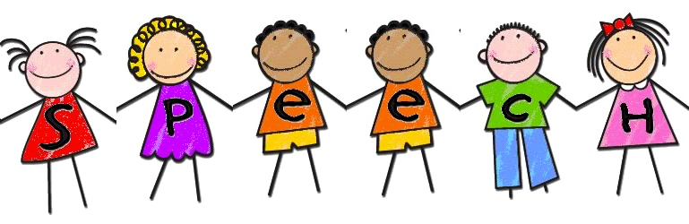

Dear Parents,

Welcome to the 2017-2018 school year. My name is Jaclyn Cleaver, and I am happy to be working as _________________’s Speech-language Pathologist this year. A little about myself… I received both my Bachelor’s and Master’s Degrees in Speech-language Pathology at Ithaca College in upstate New York. This will be my fourth year with the Flemington-Raritan School District; I was splitting my time equally between Copper Hill and the Reading-Fleming Intermediate School for the last three years. I am excited to be a full-time Dolphin this year with   
one home!

Fun Miss Cleaver Facts:

* I am a BIG New York Rangers Hockey Fan
* The Jersey Shore is my favorite place
* My favorite color is green
* My favorite animal is a pig
* My favorite food is pizza
* My favorite class in school was Speech ☺

Speech and language are important aspects of communication. I will be working with your child to help improve his/her communication abilities whether it be producing speech sounds, increasing vocabulary, improving comprehension of stories, or other aspects of language. The goal of therapy is to see skills developed in the classroom generalize into a setting outside of the therapy room. Therefore, attendance to therapy and homework completion will further support the growth of your child’s communicative abilities.

Your child will be given a folder to organize his/her assignments and to allow for communication between home and my classroom. The homework assignment log must be signed by an adult upon completion and turned in at the following speech and language session. It is encouraged to complete speech assignments with your child. Students will be able to earn stickers for completed homework and hard work during speech. For every 10 stickers collected, students will be able to choose a prize. Any assignment sent home is very important to your child’s success in speech and language.

Please don’t hesitate to contact me at any point throughout the school year with any questions or concerns that may arise. I always do my best to return phone calls or emails by the next school day. I look forward to an exciting year in speech with my new Desmares students!

Respectfully,

Jaclyn Cleaver, MS, CCC-SLP  
Speech-language Pathologist   
Francis A. Desmares Elementary School

Email: jcleaver@frsd.k12.nj.us   
Phone: (Desmares Main Office) 908- 284-7540 x 6214

I will be seeing your child on the following day(s) and times:

*There will be some changes to the schedule as the year goes on as new students come on and others “graduate.” I will do my best to keep you informed of any schedule changes.

Looking ahead… You’re child’s annual review is due by….

I will reach out a few days prior to this date to schedule a meeting!